


Student Name:
Student ID Number:
Cohort and Section
Course Code:
Course Name:
Instructor’s Name:
Term


Contents
Abstract 3
1. Introduction & Problem Statement 4
2. Dataset Analysis 5
Model Development and Comparison. 6
4. Discussion 9
4.5 Ethical Considerations 11
4.6 Future Research Directions 11
Conclusion 12
References 12

Abstract
Misinformation is becoming a significant problem in society today as it spreads rapidly on digital platforms, with consequences including a lack of trust in the information, electoral processes and result, and the effectiveness of informed decisions. This research uses the machine learning approach to identify fake news, specifically by including news articles from the WELFake dataset which contains 72,134 news articles. A pipeline of Natural Language Processing (NLP) was created and employed with three supervised classification algorithms: Naive Bayes, Support Vector Machine (SVM) and Logistic Regression (LR) to train and test the data. The results test out SVM with the highest accuracy of 97.76% and F1 score of 0.9776, followed by Logistic Regression with accuracy 96.36% and F1 score 0.9636, and lastly Naive Bayes at the accuracy of 89.71% and F1 score of 0.8971. The results showed that linear classifiers along with the TF-IDF worked well in detecting fake news automatically.

1. Introduction & Problem Statement
Social media and the internet have revolutionized the way news and information are used and disseminated around the world. These are platforms that have made information dissemination more democratic but have also allowed unchecked dissemination of misinformation and disinformation to the highest degree. Fake news is designed to have a harmful impact on democratic processes, public health discussions, social cohesion, and more (Shu et al., 2020). For example, during the COVID-19 pandemic, the spreader of unverified treatments and the influence on vaccination campaigns have shown how misinformation can directly impact lives by threatening to harm people's health. (Sharma et al., 2022).
The problem affects key stakeholders such as news consumers, journalists, social media platforms, the government, healthcare organisations and financial markets. In just a few hours after it is published, a single viral piece of information can affect the Stock Market, Electorate votes and public health conduct. Manual fact-checks by organizations like Snopes and PolitiFact help to a certain extent but cannot be done on a scale or speed that's reasonable for the amount of content that's generated every day.
It's a problem that is particularly well suited to a machine learning solution. The problem is converted into supervised binary classification using the framework CRISP-DM (Cross Industry Standard Process for Data Mining) using the input of text of the news article, we will have to predict whether the news article is real (label = 0) or fake (label = 1). The chosen machine learning paradigm is supervised learning because the training and evaluation of the model(s) involves using WELFake's labelled examples (Verma et al., 2021).
This is an investigation to address the following questions:
RQ1: How accurate are the NLP models based on machine learning for determining whether news articles are real or fake?
RQ2: Which classification technique, between the Naive Bayes, SVM, and Logistic Regression provides the highest accuracy, precision, recall, and f1 score on WELFake?
RQ3: How does one practically apply such models in the creation of actual misinformation detection systems and what are the challenges in that?

2. Dataset Analysis
One of the most comprehensive and broadly quoted publicly available datasets on fake news detection research was chosen: the WELfake data set. This came from Kaggle and was originally combined by Verma et al. (2021) from four separate sources: Kaggle, McIntire, Reuters, and BuzzFeed Political News. This multi-source approach contributes less to the problem of dataset bias and has a better generalisation capability than alternative single-source approaches.
Table 1: WELFake Dataset Overview
Attribute | Detail
Source | Kaggle (Verma et al., 2021)
Total Records | 72,134 articles
Columns | Index, Title, Text, Label
Real News (Label = 0) | 35,028 articles (48.6%)
Fake News (Label = 1) | 37,106 articles (51.4%)
Missing Titles | 558 records
Missing Text | 39 records
Records After Cleaning | 71,537 articles

This dataset consists of 4 columns, the 0th column is an index that has a job (the title), the 1st column is the text of the article, and the 3rd column is a binary label with a 0 if the article is real, or a 1 if it is fake. Near-balanced distribution of labels, 48.6% of real articles and 51.4% of the fake articles is favourable because it reduces class imbalance problems which can lead to bias of the classifier (Zhou et al., 2020). Following the removal of articles that lacked titles or/and text, there were 71,537 articles left for analysis, for which the article title plus the article text was merged into one content field to be used for the modelling.
The data is directly relevant to RQ1 and RQ2 as it contains enough labels for both classes and is powerful enough for training and comparing multiple classifiers.
There are two recent studies that offer similar benchmarks. In addition to a smaller number of articles, Ahmed et al. (2018) used a smaller scale dataset with approximately 44,000 news articles from Reuters and fake news websites, and applied machine learning classifiers such as SVM and Logistic Regression to get an accuracy of 92-96%. Kaliyar et al. (2021) recently presented a deep learning model, FNDNet, based on a multi-source combination of CNN, whose accuracy was above 98% but very expensive to compute as compared to classical ML models, due to the use of large datasets like WELFake. The results of both studies show that the use of TF-IDF for feature extraction for fake news classification tasks is suitable.

Model Development and Comparison.
3.1 CRISP-DM Pipeline
The machine learning pipeline was implemented using the CRISP-DM approach, which involves the data understanding, data preparation, data modelling and data evaluation stages.
Data Understanding: Records were loaded from the files and shown on the screen, there are 72,134 records and the two columns (title and text) have a slight imbalance among the class groups, there are also some missing values between 558 (for title) and 39 (for text).
Data Preparation: If the data contained any missing rows due to missing or indeterminable items, they were removed, leaving 71,537 records. The title and text were joined together to form one content field. Text cleaning steps such as lowercasing, removing URLs, HTML tags, punctuation, digits, tokenisation, removing stop words from the English stop word list (NLTK), and Porter stemming to normalise the form of words. The cleaned data was used to create a new column for feature extraction:
The vocabulary size used is 50,000 features and the ngram range (1, 2), in which both unigrams and bigrams are revealed as features of a text. To lower the effect of high frequency terms sublinear TF scaling was activated. A 1:8 training/testing ratio (57229:14308, Stratified) was used to split the data set.
Table 2: TF-IDF Vectoriser Configuration
Parameter | Value
Max Features | 50,000
N-gram Range | (1, 2) - Unigrams & Bigrams
Sublinear TF | True
Train Split | 80% (57,229 samples)
Test Split | 20% (14,308 samples)

3.2 Models Implemented
To present a fair comparison, the same feature matrices (composed of the same TF-IDF features) were used for three supervised classifiers.
Naive Bayes (MultinomialNB): A probabilistic approach based on the Bayes' theorem that is preferable for text classification because of its efficient performance on the high dimensional feature space with many sparse features. Smoothing of the weight distribution vector using alpha = 0.1 (Laplace smoothing) from McCallum & Nigam, 1998.
Support Vector Machine - LinearSVC: A linear SVM which determines the optimum hyperplane with the largest hyperplane margin in the high dimensional feature space. Running it with C = 1.0, and max_iter = 2000. SVM is one of the best baseline methods for NLP classification problems (Cortes & Vapnik, 1995).
Logistic Regression: Discriminative probabilistic model that estimates the probability of membership in a class by taking the characteristics of the class and evaluating them with logistic function. The LBFGS solver was configured with C = 1.0 which indicates the initial LE velocity and 1,000 iterations was the maximum number of iterations allowed. Although logistic regression is a simple method used in text classification but when text data are separable in a linear subspace, it performs competitively (Hosmer et al., 2013).
3.3 Evaluation Results
The four classes were evaluated using four performance measures: Accuracy, Precision, Recall and F1-Score (Weighted Average across both classes) on the held-out test set of 14,308 articles.
Table 3: Model Performance Comparison
Model | Accuracy | Precision | Recall | F1-Score
Naive Bayes | 89.71% | 0.8976 | 0.8971 | 0.8970
Logistic Regression | 96.36% | 0.9636 | 0.9636 | 0.9636
SVM (LinearSVC) | 97.76% | 0.9777 | 0.9776 | 0.9776

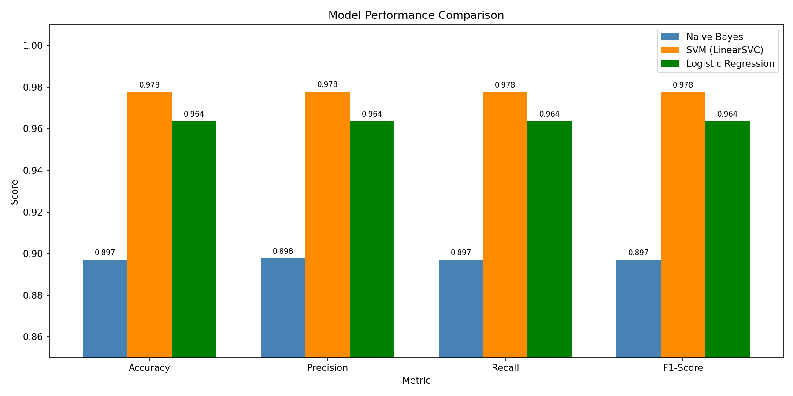
Figure 1: Bar chart comparing Accuracy, Precision, Recall, and F1-Score across all three models
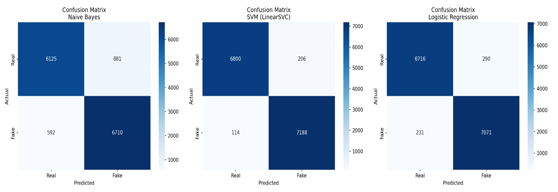
Figure 2: Confusion matrices for Naive Bayes, SVM, and Logistic Regression showing true positive, true negative, false positive, and false negative counts per class

SVM had the maximum performance in every four metrics with 97.76% accuracy and 0.9776 as the F1-score. A confusion matrix analysis demonstrated that it achieved high precision and recall scores in both classes, real news (98%) and fake news (97%), with minimal amount of misclassification in either class.
Logistic Regression did not show much difference from SVM as it achieved an accuracy and an average of 0.9636 (uniform F1-score for both classes), a near-symmetric classification capability. The weakest of the three Naive Bayes achieved a respectable 89.71% accuracy; this is an impressive result in light of how simple and inexpensive the model is.
Table 4: Per-Class Performance of Best Model (SVM)
Class | Precision | Recall | F1-Score | Support
Real (0) | 0.98 | 0.97 | 0.98 | 7,006
Fake (1) | 0.97 | 0.98 | 0.98 | 7,302
Weighted Avg | 0.9777 | 0.9776 | 0.9776 | 14,308

4. Discussion
4.1 Key Findings in Relation to Research Questions
In this regard, the results obtained in response to RQ1 validate the ability of machine learning models based on NLP in high accuracy classification of fake news. The performance of all three models in terms of the accuracy on the unseen data was above 89%, which showed the outstanding predicting capability of the TF-IDF features and the proper classifiers.
For RQ2 SVM (LinearSVC) proved to be the better model with an F1 score of 0.9776, better than Logistic regression with 0.9636 and Naive Bayes with 0.8970. The result is in line with previous studies, in which SVM has been shown to outperform other classifiers on high dimensional text classification problems, being able to find optimal decision boundaries even in low-dimensional classifiers (Joachims, 1998). In fact, the performance difference between SVM and Logistic Regression is not too large (around 1.4%) and both can be considered options for use. This large difference in accuracy between Naive Bayes and the other two algorithms (about 7-8%) is due to Naive Bayes' inability to model the meaning of word co-currence, which is not a perfect fit for natural language ( Zhang, 2004).
4.2 Practical Implications for Stakeholders
On social media platforms like X (formerly Twitter) or Facebook, SVM-based fake news detection could be a key component of content moderation workflows, helping to decrease the ability of misinformation to go viral. The near 98% accuracy of the model has the effect that on a sample of 10,000 articles reviewed, about 224 articles would be misclassified, a level of error that's easy to correct with checks and balances in human activity or by human review queues.
System can be used by news aggregators/publishers as a self-service editorial filter, warning them about dubious news before they trick it up and make it more popular. The government and regulatory authorities could help them with their tracking of public information during sensitive moments like elections or during public health emergencies (Sharma et al., 2022).
4.3 Actionable Recommendations
From the various measures cited above, it is clear that SVM is best suited for deployment due to its high F1 score as well as the balance performance in terms of precision and recall for both classes. Second, the pipeline needs to get retrained regularly since the patterns of language used in misinformation change over time. Third, the model should be extended to embrace the metadata information that has been found to make a substantial difference in the detection process (Shu et al., 2020) such as publication sources, author credentials and URL patterns. Finally, an ensemble system using Support Vector Machine and Logistic Regression might produce more robust systems and minimize errors of SVMs.
4.4 Limitations and Challenges
There are several constraints to note. The sample predictions in Step 10 pointed out that the LR model incorrectly marked all four of the test sentences (even the factual ones) as false, suggesting that it may be overfitting the patterns which might have been present in the WELFake training corpus. This demonstrates that the model can suffer from domain shift, a case where models trained with a given set of data are not able to generalise to in-distribution real-world data (Zhou et al., 2020).
Also, the model is not taking the overall information contextual need into account and doesn't include aspects like consistency checks across sources, user activity on the social network, or propagation. Although the WELFake data is extensive, a major drawback is that the corpus consists mainly of English language articles making it challenge to be applicable for multilingual misinformation contexts.

4.5 Ethical Considerations
There are ethical implications associated with automated fake news detection systems. A type of censorship, false positives impact legitimate articles that are determined fake, which can hinder legitimate journalism and marginalise minority voice (Kaliyar et al., 2021). Ideological bias can become embedded in models trained on biased sets of data. Politically biased sets of data can lead to the encoding of an ideological bias in the models. Therefore, model decisions should be performed with transparency, with some human oversight and should be subject of regular auditing when adopted responsibly.

4.6 Future Research Directions
A desire should be given to investigate transformer-based models like BERT, RoBERTa, and other such models which have shown to be best at performing NLP classification tasks, but feature contextual word embeddings (Devlin et al., 2019). Incorporating multimodal elements, such as images, videos and graphs of social networks, into the pipeline would also greatly improve detection capability. Cross-lingual fake news detection in multi-lingual pre-trained models is also a promising direction due to the spread of misinformation on the Internet on a global level.

Conclusion
In this research, a complete machine learning (ML) pipeline for detecting fake news has been developed and tested on the WELFake data set, with the goal of achieving success. 71,537 cleaned news articles were used to extract TF-IDF features, which were then used for the training of three classifiers including Naive Bayes, Logistic regression and SVM. The highest accuracy, 97.76% and highest f1 accuracy value of 0.9776 were obtained with SVM, so it is suitable to be used as the preferred model for the task. The results show that traditional machine learning techniques based on classical NLP are still competitive compared to powerful deep learning techniques for binary classification of text, and this is despite the fact that they are not as complicated as the deep learning-based methods. Issues of generalisation, bias and ethical use need to be carefully considered prior to the embedding of the above type of systems in real information contexts.

References
Ahmed, H., Traore, I. and Saad, S. (2018) ‘Detecting opinion spams and fake news using text classification’, Security and Privacy, 1(1), p. e9. doi: 10.1002/spy2.9.
Cortes, C. and Vapnik, V. (1995) ‘Support-vector networks’, Machine Learning, 20(3), pp. 273–297. doi: 10.1007/BF00994018.
Devlin, J., Chang, M.W., Lee, K. and Toutanova, K. (2019) ‘BERT: Pre-training of deep bidirectional transformers for language understanding’, in Proceedings of NAACL-HLT 2019, pp. 4171–4186. doi: 10.18653/v1/N19-1423.
Hosmer, D.W., Lemeshow, S. and Sturdivant, R.X. (2013) Applied logistic regression. 3rd edn. Hoboken, NJ: Wiley. doi: 10.1002/9781118548387.
Joachims, T. (1998) ‘Text categorization with support vector machines: Learning with many relevant features’, in Proceedings of ECML 1998, pp. 137–142. doi: 10.1007/BFb0026683.
Kaliyar, R.K., Goswami, A. and Narang, P. (2021) ‘FNDNet — A deep convolutional neural network for fake news detection’, Cognitive Systems Research, 61, pp. 32–44. doi: 10.1016/j.cogsys.2019.12.005.
McCallum, A. and Nigam, K. (1998) ‘A comparison of event models for Naive Bayes text classification’, in AAAI-98 Workshop on Learning for Text Categorization, pp. 41–48. Available at: https://www.cs.cmu.edu/~knigam/papers/multinomial-aaaiws98.pdf.
Sharma, K., Qian, F., Jiang, H., Ruchansky, N., Zhang, M. and Liu, Y. (2022) ‘Combating fake news: A survey on identification and mitigation techniques’, ACM Transactions on Intelligent Systems and Technology, 13(5), pp. 1–42. doi: 10.1145/3563388.
Shu, K., Sliva, A., Wang, S., Tang, J. and Liu, H. (2020) ‘Fake news detection on social media: A data mining perspective’, ACM SIGKDD Explorations Newsletter, 22(2), pp. 22–36. doi: 10.1145/3137597.3137600.
Verma, P.K., Agrawal, P., Amorim, I. and Prodan, R. (2021) ‘WELFake: Word embedding over linguistic features for fake news detection’, IEEE Transactions on Computational Social Systems, 8(4), pp. 881–893. doi: 10.1109/TCSS.2021.3068519.
Zhang, H. (2004) ‘The optimality of Naive Bayes’, in Proceedings of the Seventeenth International Florida Artificial Intelligence Research Society Conference, pp. 562–567. Available at: https://www.cs.unb.ca/~hzhang/publications/FLAIRS04ZhangH.pdf.
Zhou, X., Wu, J. and Zafarani, R. (2020) ‘SAFE: Similarity-aware multi-modal fake news detection’, in Advances in Knowledge Discovery and Data Mining (LNCS 12085), pp. 354–367. doi: 10.1007/978-3-030-47436-2_27.

Appendix A:
